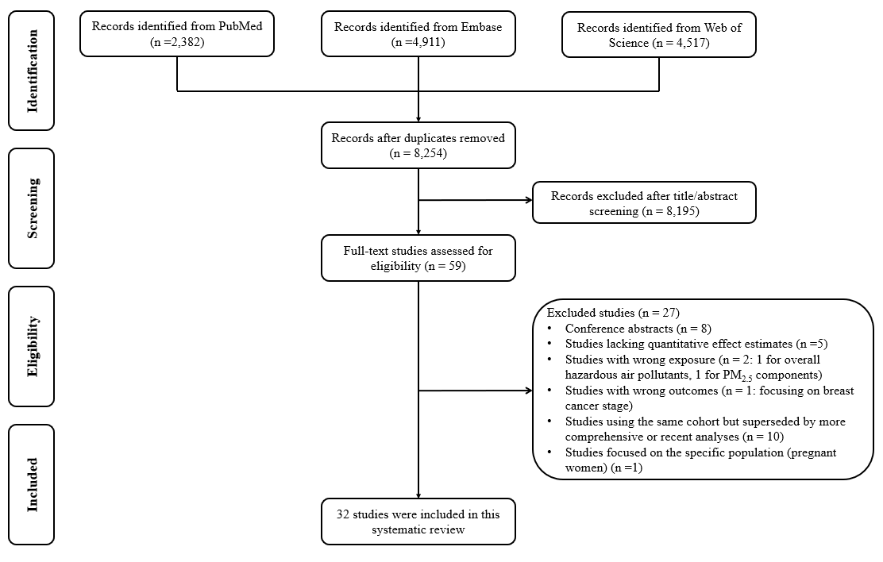
Figure 1 The Preferred Reporting Items for Systematic Reviews and Meta-Analyses (PRISMA) flow diagram of the study selection process

Table 1 The characteristics and detailed information of 32 studies included in this systematic review
Study | Study region | Study design | Study population | Cases (N, %) | PM | PM concentration (Mean ± SD / Median (Q1, Q3), µg/m³) | Adjusted covariates | Effect estimates
Wu, 2024 | US | Cohort | 58,358 | 3,524 (6.0%) invasive cases | PM_{2.5}, PM₁₀ | PM_{2.5}: 17.5 (16.4, 18.5)  PM₁₀: 36.2 (34.6, 38.2) | Age (time scale), and stratum by age at cohort entry (by 1 year) and neighbourhood socio-economic status (nSES) at baseline, race/ethnicity, smoking, alcohol, total energy, education, nSES current, BMI, physical activity, age at menarche, parity, age at first birth, type of menopause, and hormonal therapy | PM_{2.5}: 1.28 (1.09, 1.51) for per 10 μg/m³ increase in 3,524 cases  PM₁₀: 0.98 (0.90, 1.07) for per 10μg/m³ increase in 3,524 cases
White, 2021 | US | Cohort | 41,317 | 2,146 (5.2%) | PM_{2.5} | 13.9 ± 2.3 | Age (time scale), information at baseline for education, smoking status, parity, hormone therapy (HT) use, BMI, geographic region, menopausal status, and menopausal status*BMI | PM_{2.5}: 0.98 (0.93,1.03) for per IQR increase (2.87μg/m³)
Terre-Torras, 2022 | Spain | Cohort | 1,798,838 | 6,126 (0.6%) premenopausal, 17,858 (2.4%) postmenopausal | PM_{2.5}, PM₁₀ | PM_{2.5}: 14.90 (13.65, 15.48)  PM₁₀: 34.21 (30.09, 37.92) | Stratified by age in 5-year intervals, nationality, BMI, smoking status, alcohol risk, and MEDEA deprivation index (socioeconomic status) | PM_{2.5}: 1.02 (1.01-1.03) for per IQR increase (1.83 μg/m³) in 23,984 cases  PM₁₀: 1.03 (1.01-1.05) for per IQR increase (7.83 μg/m³) in 23,984 cases
White, 2019 | US | Cohort | 49,771 | 2,852 (5.7%) | PM_{2.5}, PM₁₀ | PM_{2.5}: IQR = 3.6  PM₁₀: IQR = 5.8 | Age, race/ethnicity, education, smoking status, and menopausal hormone therapy, household income, census-tract income, marital status, parity, and BMI | PM_{2.5}: 1.04 (0.98, 1.10) for per IQR increase (3.6 μg/m³) in 2,820 cases  PM₁₀: 1.01 (0.97, 1.05) for per IQR increase (5.8 μg/m³) in 2,820 cases
White, 2024 | US | Cohort | 199, 750 | 15,870 (7.9%) | PM_{2.5} | 1980-1984: 18.70 ± 3.68 1985-1989: 17.15 ± 3.46 1990-1994: 15.60 ± 3.25 | Age, race and ethnicity, smoking status, body mass index, catchment area, and educational attainment, reproductive factors (age at first live birth, parity, oral contraceptive use, menopausal hormone use, age at menarche, and first-degree relative with a history of breast cancer) | PM_{2.5}: 1.06 (1.00, 1.11) for per 10 μg/m³ increase in 15,433 cases
Smotherman, 2023 | UK | Cohort | 155,235 postmenopausal women | 6,146 (4.0%) | PM_{2.5}, PM₁₀ | PM_{2.5} (2010): 9.95 ± 1.04  PM₁₀ (2007): 22.00 ± 2.86  PM₁₀ (2010): 16.20 ± 1.89 | Age at recruitment, age at menarche, BMI, race/ethnicity, parity/age at first child’s birth, family history of breast cancer in first degree relatives, age at menopause, postmenopausal hormone use, smoking, and alcohol consumption (Baseline) | PM_{2.5} (2010): 0.86 (0.66, 1.12) for per 10 μg/m³ increase in 5,321 cases  PM₁₀: 1.99 (1.75, 2.27) for per 10 μg/m3 increase in 6,128 cases
Song, 2024 | China | Cohort | 85,504 | 864 (1.0%) | PM_{2.5} | 77.37 ± 10.70 | Age, ethnicity, educational level, marital status, smoking status, second-hand smoke exposure, exposure to cooking fumes, consumption of salted foods, alcohol consumption, tea consumption, physical activity, self-reported trauma or depression, reproductive history, benign breast diseases, potentially relevant diseases, family history of breast cancer or other tumours, BMI | PM_{2.5}: 1.02 (1.01, 1.03) for per 1 μg/m³ increase
Kayyal-Tarabeia, 2024 | Israeli | Cohort | 479,287 | 5,793 (1.2%) | PM_{2.5} | 21.20 ± 1.49 | Baseline age, sex, ethno-religion, country of origin, area-level socio-economic status (SES), population density, urbanicity, peripheral index and residential greenness, baseline education | PM_{2.5}: 1.50 (1.42, 1.58) for per IQR increase (2.11 µg/m³)
Hvidtfeldt, 2023 | Europe | Cohort | 199,719 | 9,659 (4.8%) | PM_{2.5} | 15.10 ± 3.20 | Age (time scale), (sub) cohort ID (included as strata), and adjustment for year of enrolment, marital status, employment status, BMI, smoking status, smoking duration and smoking intensity for current smokers, area-level mean income in 2001, as a proxy for SES | PM_{2.5}: 1.06 (1.01, 1.11) for per 5 μg/m3 increase
Bai, 2020 | Canada | Cohort | 2,564,340 | 91,146 (3.6%) | PM_{2.5} | 7.69 ± 1.85 | Age at baseline, stratified by region (living in Toronto or not), census tract-level recent immigrants (arrived in the 5 years prior to census), unemployment rate, education, and annual household income, urban residency and a north/south indicator, selected comorbidities (hypertension, diabetes, COPD and asthma), neighbourhood deprivation. Health care access, potential behavioural risk factor | PM_{2.5}: 1.00 (0.98, 1.02) for per IQR increase (5.3 μg/m³)
Andersen, 2017a | Europe | Cohort | 74,750 postmenopausal women | 3,612 (4.8%) | PM_{2.5}, PM₁₀ | PM_{2.5}: 7.3 ± 1.3 in CEANS to 30.2 ± 1.6 IN EPIC-urin  PM₁₀: 13.4 ± 3.1 in HUBRO to 46.6 ± 4.1 IN EPIC-urin | Age (time scale) and calendar time (years of enrolment), smoking status, smoking intensity, smoking duration, alcohol consumption, physical activity in leisure time, BMI, educational level, employment, parity, age at first child birth, postmenopausal HT use, HT use duration, mean income of the neighbourhood or municipality, in the majority of cohorts | PM_{2.5}: meta-analysis: 1.08 (0.77, 1.51) for per 5 μg/m3 increase  (1) HUBRO-Oslo: 1.35 (0.55, 3.29) for per 5 μg/m3 increase  (2) CEANS-Stockholm: 1.42 (0.84, 2.39)  (3) DCH-Copenhagen: 1.31 (0.83, 2.07)  (4) EPIC-Netherlands: 0.65 (0.28, 1.51)  (5) EPIC-London/Oxford: 1.54 (0.77, 3.10)  (6) VHM&PP-Voralberg: 0.65 (0.47, 0.88)  (7) EPIC-Turin: 1.26 (0.60, 2.64)  PM₁₀: meta-analysis: 1.07 (0.89, 1.30) for per 10 μg/m³ increase  (1) HUBRO-Oslo: 1.73 (0.82, 3.65)  (2) CEANS-Stockholm: 1.05 (0.77, 1.45)  (3) DCH-Copenhagen: 1.09 (0.74, 1.62)  (4) EPIC-Netherlands: 0.83 (0.40, 1.74)  (5) EPIC-London/Oxford: 1.41 (0.77, 2.60)  (6) VHM&PP-Voralberg: 0.81 (0.59, 1.12)  (7) EPIC-Turin: 1.57 (0.86, 2.86)
Andersen, 2017b | Denmark | Cohort | 22,877 nurses | 1,145 invasive cases (5.0%) | PM_{2.5}, PM₁₀ | PM_{2.5}: 19.7 ± 3.5  PM₁₀: 23.5 ± 3.9 | Stratified by year of birth, age adjusted, smoking (status and intensity), alcohol consumption, physical activity, BMI, age at first birth, parity, age at menarche, HT use, oral contraceptive use, menopausal status | PM_{2.5}: 1.00 (0.91,1.09) for per IQR increase (3.3 μg/m³)  PM₁₀: 1.02 (0.94,1.11) for per IQR increase (2.9 μg/m³)
Hart, 2016 | US | Cohort | 115,921 nurses | 3,416 invasive cases (2.9%) | PM_{2.5}, PM₁₀ | Not mentioned | Age, race, and calendar year, history of breast benign disease, family history, age at menarche, parity, age at first birth, height, BMI at age 18, current BMI, alcohol consumption at ages 15-17 and 18-22, overall diet quality (AHEI-2010), oral contraceptive use, menopausal status and hormone use, smoking status, physical activity, individual level socioeconomic status (marital status, living arrangements, household income) and area level socioeconomic status (Census tract level median income and median home value), and region of residence | PM_{2.5}: 0.90 (0.79, 1.03) for per 10 μg/m³ increase  PM₁₀: 1.00 (0.93, 1.07) for per 10 μg/m³ increase
Sun, 2025 | China | Cohort | 281,152 | 2,393 (0.9%) | PM_{2.5} | 52.48 (43.70, 59.08) | Age, highest education, region, marital status, household income and BMI, physical activity, tobacco smoking, alcohol consumption, passive smoking, family history of cancer and satisfaction level of life | PM_{2.5}: 1.07 (1.03, 1.12) for per 10 μg/m³ increase
Datzman, 2018 | German | Cohort | 1,918,449 | 9,577 (0.5%) | PM₁₀ | PM₁₀ from 15.47 to 26.30 (Mean = 20.89) | Age, alcohol-related disorder, absolute number of physician contacts, short- (up to one year) and long-term unemployment (>1 year) rate | PM₁₀: RR (95%CI) = 1.19 (1.09, 1.31) for per 10 µg/m³ increase
Huang, 2022 | China | Cohort | 407,415 | 2,917 (0.7%) | PM_{2.5} | 20.95 ± 5.69 | Age, sex, region, education, percent body fat, hypertension, history of nephritis, long-term use of uric acid (UA) medication, smoking, alcohol consumption, physical activity, occult blood, UA, alkaline phosphatases (ALP), serum glutamic-oxaloacetic transaminase (SGOT), and alpha-fetoprotein (AFP) | PM_{2.5}: 1.12 (1.03, 1.22) for per 10 μg/m³ increase
Villeneuve, 2018 | Canada | Cohort | 89,247 | 6,427 (7.2%) | PM_{2.5} | 9.10 (6.40, 12.40) | Occupation, marital status, education, BMI, cigarette pack-years, ever pregnant, oral contractive use, HT use, age at menarche, breast self-examination, family history of breast cancer, median income, high school education, low-income households, and unemployment rate | PM_{2.5}: 1.01 (0.94, 1.10) for per 10 μg/m³ increase
Li, 2021 | China | Cohort | 96,643 | Q1: 224 (0.2%)  Q2: 181 (0.2%)  Q3: 179 (0.2%)  Q4: 213 (0.2%) | PM_{2.5} | Not mentioned | Age, sex, monthly income, and urbanization level | PM_{2.5}: Q2: 1.11 (0.92, 1.36)  Q3: 1.08 (0.89, 1.32)  Q4: 1.29 (1.07, 1.56)
White, 2025 | US | Cohort | 393,547 | 20,197 | PM_{2.5} | NHS 12.0 (10.3, 14.0) NHSII 12.9 (11.0, 14.5); SIS 10.8 (8.8, 12.4); WHI-CT 12.9 (10.5, 14.9)  WHI-OS 13.0 (10.6, 15.0) | Race and ethnicity, educational attainment, nSES score, time-varying census region; WHI-CT additionally adjusted for hormone therapy treatment arm | PM_{2.5}: meta-analysis: 0.99 (0.96, 1.02) for per 5 μg/m3 increase  (1) NHS: 1.00 (0.94, 1.06)  (2) NHSII: 0.97 (0.90, 1.04)  (1) SIS: 0.96 (0.86, 1.06)  (1) WHI-CT: 0.99 (0.92, 1.06)  (1) WHI-OS: 1.02 (0.95, 1.09)
Feng, 2025 | US | Cohort | 8,371,588 | 424,426 | PM_{2.5} | Not reported | Age, sex, race, postcode of residence, Medicaid eligibility, percentage of older adults in poverty, below high school education, Black, White, needing public assistance, median household income, ambulatory visit rate, mammography rate, distance to nearest hospital, smoking prevalence, and census division. | PM_{2.5}: IRR (95% CI) = 1.003 (1.002, 1.005) for per 1μg/m3 increase
Poulsen, 2023 | Denmark | Case-control | 111,490 | 55,745 (50.0%) | PM_{2.5} | Cases: 17.36 (15.85, 19.11)  Controls: 17.30 (15.81, 19.02) | Age, education, personal income in deciles, marital status, occupational status, region of origin, use of aspirin, non-aspirin non-steroidal anti-inflammatory drug (NSAID), oral contraceptives, HT, asthma or allergy medication, percentages of adult parish population in the lowest income quartile, unemployed, retired, doing manual labour, owning their own dwelling, living in social housing, being of Danish origin, previously convicted of a crime, single parent families and having basic education as highest attained education level | PM_{2.5}: OR (95% CI) = 1.21 (1.11, 1.33) for per 10 μg/m³ increase
Lemarchand, 2021 | France | Case-control | 2,493 | 1,201 (48.2%) | PM_{2.5}, PM₁₀ | PM_{2.5}: Cases: 13.7 ± 1.3 Controls: 13.6 ± 1.3  PM₁₀: Cases: 21.7 ± 1.6 Controls: 21.6 ± 1.6 | Age and study area, history of breast cancer in first degree relatives, age at menarche, parity, age at first full-term pregnancy, current use of hormone replacement therapy for postmenopausal and physical activity | PM_{2.5}: OR (95% CI) = 1.02 (0.95, 1.08) for per 1 μg/m³ increase  PM₁₀: OR (95% CI) = 1.01 (0.96, 1.06) for per 1 μg/m³ increase
Goldberg, 2018 | Canada | Case–control | 788 | 375 invasive, postmenopausal cases (47.6%) | UFPs | 24,937 ± 6,759 /cm3 | Age, family history, age of bilateral oophorectomy, education, ethnicity, age at menarche, age at first full-term pregnancy, cumulative number of weeks of breast feeding, number of years of oral contraceptive use, use of hormonal replacement therapy, body mass index 2 years before diagnosis, tobacco exposure, alcohol status, proxy interview, unemployment rate, low education and median household income | UFP: OR (95% CI) = 1.08 (0.96, 1.21) for per IQR μg/m³ increase (4,719 /cm³)
Goldberg, 2017 | Canada | Case-control | 1,277 | 681 (53.3%) | UFPs | 24248.4 ± 5568.0 /cm3 | Age, family history, age of bilateral oophorectomy, education, ethnicity, age at menarche, age at first full-term pregnancy, cumulative number of weeks of breast feeding, number of years of oral contraceptive use, use of hormonal replacement therapy, BMI 2 years before diagnosis, active and passive smoking at home, alcohol status, number of full-term pregnancies, unemployment rate, low education and median household income | UFP: OR (95% CI) = 1.01 (0.93, 1.09) for per IQR μg/m³ increase (3845.3 /cm³)
Provost, 2024 | Canada | Case-control | 707 | 465 (65.8%) | PM_{2.5} | Mean = 7.7 | Age, ethnicity, educational level, household income, BMI two years prior interview, and smoking status two years prior interview, alcohol consumption two years prior interview, age at menarche, family history of breast cancer, parity, age at first pregnancy, history of benign breast disease, and ever oral contraceptive use | PM_{2.5}: OR (95% CI) = 0.96 (0.64, 1.42) for per IQR increase (1.8 μg/ m³)
Praud, 2026 | France | Case-control | 10.444 | 5,222 invasive cases | PM_{2.5}, PM₁₀ | PM_{2.5}: 29.1 (9.3) in 1990; 16.2 (4.3) in 2011  PM₁₀: 38.0 (10.5) in 1990; 22.2 (5.7) in 2011 | Education level, urban/rural status at inclusion, age at menarche, menopausal status at index date, family history of breast cancer, benign breast disease. | PM_{2.5}: OR (95% CI) = 1.13 (0.98, 1.30) for per 10 μg/m3 increase  PM₁₀: OR (95% CI) = 1.07 (0.97, 1.17) for per 10 μg/m3 increase
Zhang, 2023 | 162 countries | Ecological | 162 countries | 1422.16 (454.20, 5575.84) | PM_{2.5} | 14.90 (9.50, 24.73) | Population density, the proportion of older adults, the proportion of women who smoke, gross domestic product (GDP) per capita, urbanization rate, number of doctors per 1000 population, year, and rainfall | PM_{2.5}: RR (95%CI) = 1.04 (1.02,1.05) for per IQR increase (15.23 μg/m³)
Craver, 2024 | US | Ecological | 247,877 | 11,121 (4.5%) | PM_{2.5} | Mean = 8.90 | Age, sex, race/ethnicity, current smoking status, education, and BMI | PM_{2.5}: 1.03 (1.02, 1.04) for per unit increase
Coleman, 2020 | US | Ecological | 607 counties | 1992-2016: 1,473,349  2008-2016: 705,738 | PM_{2.5} | 1988-2015: 11.50 ± 2.60 1999-2015: 10.00 ± 2.20 1988-2007: 12.70 ± 3.10 | Percentage of the county in various age buckets; percentage male; percentage white, black, Hispanic, and other; percentage who did not graduate high school, graduated high school, or obtained more education than high school; median income, rent, and home value; percentage below 150% poverty; percentage working class; percentage unemployed; percentage living in a rural area; percentage smokers; percentage alcohol consumption; percentage who are physically active; and percentage of individuals in a county who are obese; indicator variables for urban vs. rural and state | PM_{2.5}: IRR (95% CI) = 1.07 (1.00, 1.16) for per 10 μg/m³ increase
Hwang, 2020 | South Korea | Ecological | 252 districts | Age-adjusted breast cancer incidence rate (per 100,000): Median (Q1, Q3) = 41.6 (35.2–46.5) | PM₁₀ | No specific data | Altitude, rate of higher education, smoking rate, obesity rate, and Gross Regional Domestic Product per capita | PM₁₀: OR (95% CI) = 1.13 (1.09, 1.17) for per 10 μg/m³ increase
Zhao, 2020 | US | Ecological | 1,277 counties | 1,919 | PM_{2.5} | 11.27 ± 1.70 | Black, API (Asian/Pacific Islander), Hispanic, PCPrate (rate of primary care provider), pUnins (percent of population without health insurance), medIncome (median household income), pHWFH (percent of husband-wife family households), FMedAge (female median age) | PM_{2.5}: Coefficients Beta (95% CI) = 0.48 (0.15, 0.81) for per 1 μg/m³ increase
Parikh, 2016 | US | Ecological | Atlanta and Georgia (13 regions) | Atlanta: 132.6 (131.2, 134.0) per 100,000  Georgia: 113.7 (108.2, 119.5) per 100,000 | PM_{2.5} | Emission density: Atlanta: 8.09 ton/sq mile  Georgia: 1.75 ton/ sq mile | County poverty level | PM_{2.5}: Coefficients Beta (95% CI) = 2.96 (0.47, 5.46)
Abbreviations: N, %: The number of cases (percentage of cases); Q1: 25th percentiles; Q2: 50th percentiles Q3: 75th percentiles; Q4: 100th percentiles SD: standard deviation; OR: odds ratio; HR: hazard ratio; RR: relative risk; IRR: incidence rate ratio; CI: confidence interval; IQR: inter-quartile range
Studies highlighted in grey were excluded from the meta-analysis because their reported results could not be converted to a standardised effect estimate per 10 μg/m³ increase
Studies highlighted in orange were excluded from the meta-analysis because they were identified as influential studies (Appendix Table S4A & S5A)
Studies highlighted in green focused on ultrafine particles (UFPs) and were excluded from the meta-analysis due to the limited number of available studies
For the main meta-analysis, ecological studies were excluded due to the significantly different study designs (using aggregated data instead of individual data)
Table 2 Quality assessment for each included study using adapted Newcastle-Ottawa Scale (NOS)
Reference | Selection |  |  |  | Comparability |  | Exposure/Outcome |  |  | Quality score
Reference | S1 | S2 | S3 | S4 | C1a | C1b | E/O1 | E/O2 | E/O3 | Quality score
Wu, 2024* | ☆ | ☆ | ☆ | ☆ | ☆ | ☆ | ☆ | ☆ |  | 8
White, 2021* | ☆ | ☆ | ☆ | ☆ | ☆ | ☆ | ☆ | ☆ |  | 8
Terre-Torras, 2022* | ☆ | ☆ | ☆ | ☆ | ☆ | ☆ | ☆ | ☆ |  | 8
White,2019* |  | ☆ | ☆ | ☆ | ☆ | ☆ | ☆ | ☆ | ☆ | 8
White, 2024* | ☆ | ☆ | ☆ | ☆ | ☆ | ☆ | ☆ | ☆ |  | 8
Smotherman, 2023* | ☆ | ☆ | ☆ | ☆ | ☆ | ☆ | ☆ | ☆ |  | 8
Song, 2024* | ☆ | ☆ | ☆ | ☆ | ☆ | ☆ | ☆ | ☆ |  | 8
Kayyal-Tarabeia, 2024* | ☆ | ☆ | ☆ | ☆ | ☆ | ☆ | ☆ | ☆ |  | 8
Hvidtfeldt, 2023* | ☆ | ☆ | ☆ | ☆ | ☆ | ☆ | ☆ | ☆ |  | 8
Bai, 2020* | ☆ | ☆ | ☆ | ☆ | ☆ | ☆ | ☆ | ☆ |  | 8
Andersen, 2017a* | ☆ | ☆ | ☆ | ☆ | ☆ | ☆ | ☆ | ☆ |  | 8
Andersen, 2017b* |  | ☆ | ☆ | ☆ | ☆ | ☆ | ☆ | ☆ |  | 7
Hart, 2016* |  | ☆ | ☆ | ☆ | ☆ | ☆ | ☆ | ☆ |  | 7
Sun, 2025* | ☆ | ☆ | ☆ | ☆ | ☆ | ☆ | ☆ | ☆ |  | 8
Datzmann, 2018* | ☆ | ☆ | ☆ | ☆ | ☆ | ☆ | ☆ | ☆ |  | 8
Huang, 2022* | ☆ | ☆ | ☆ | ☆ | ☆ | ☆ | ☆ | ☆ |  | 8
Villeneuvea, 2018* | ☆ | ☆ | ☆ | ☆ | ☆ | ☆ | ☆ | ☆ |  | 8
Li, 2021* | ☆ | ☆ | ☆ | ☆ | ☆ | ☆ | ☆ | ☆ |  | 8
White, 2025 * | ☆ | ☆ | ☆ | ☆ | ☆ | ☆ | ☆ | ☆ | ☆ | 9
Feng, 2025 * | ☆ | ☆ | ☆ | ☆ | ☆ | ☆ | ☆ | ☆ |  | 8
Poulsen, 2023** | ☆ | ☆ | ☆ | ☆ | ☆ | ☆ | ☆ | ☆ |  | 8
Lemarchand, 2021** | ☆ | ☆ | ☆ | ☆ | ☆ | ☆ | ☆ | ☆ |  | 8
Goldberg, 2018** | ☆ | ☆ |  | ☆ | ☆ | ☆ | ☆ | ☆ | ☆ | 8
Goldberg, 2017** | ☆ | ☆ | ☆ | ☆ | ☆ | ☆ | ☆ | ☆ | ☆ | 9
Provost, 2024** | ☆ | ☆ | ☆ | ☆ | ☆ | ☆ | ☆ | ☆ |  | 8
Praud, 2026** | ☆ | ☆ | ☆ | ☆ | ☆ | ☆ | ☆ | ☆ |  | 8
Zhang, 2023*** | ☆ | ☆ | ☆ | ☆ | ☆ |  | ☆ | ☆ | ☆ | 8
Craver, 2024*** | ☆ | ☆ | ☆ | ☆ | ☆ | ☆ | ☆ | ☆ | ☆ | 9
Coleman, 2020*** | ☆ | ☆ | ☆ | ☆ | ☆ | ☆ | ☆ | ☆ | ☆ | 9
Hwang, 2020*** | ☆ | ☆ | ☆ | ☆ | ☆ |  | ☆ | ☆ | ☆ | 8
Zhao, 2020*** | ☆ | ☆ | ☆ | ☆ | ☆ | ☆ | ☆ | ☆ | ☆ | 9
Parikh, 2016*** | ☆ | ☆ | ☆ | ☆ |  |  | ☆ | ☆ | ☆ | 7
High quality: 7-9 scores; Moderate quality: 4-6 scores; Low quality: ≤3 scores
*: Cohort study: S1: Representativeness of the exposed cohort; S2: Selection of the non-exposed cohort; S3: Ascertainment of exposure; S4: Demonstration that outcome of interest was not present at start of study; C1: Comparability of cohorts on the basis of the design or analysis; O1: Assessment of outcome; O2: Was follow-up long enough for outcome to occur; O3: Adequacy of follow up of cohorts
**: Case-control study: S1: Is the case definition adequate; S2: Representativeness of the cases; S3: Selection of controls; S4: Definition of controls; C1: Comparability of cases and controls on the basis of the design or analysis; E1: Ascertainment of exposure; E2: Same method of ascertainment for cases and controls; E3: Non-response rate
***: Ecological study: S1: Representativeness of the exposed population; S2: Representativeness of the non-exposed population; S3: Ascertainment of exposure; S4: Demonstration that outcome of interest was not present at the start of study; C1: Comparability of exposed and non-exposed groups on the basis of the design or analysis; O1: Assessment of outcome; O2: Statistical analysis quality; O3: Ecological bias awareness
Table 3 Risk of bias for each included study using National Toxicology Program/Office of Health Assessment and Translation (NTP/OHAT)
Bias domains |  | Questions |  |  | Wu, 2024 | White, 2021 |  | Terre-Torras, 2022 |  |  | White, 2019 | White, 2024 | Smotherman, 2023 |  | Song, 2024 |  | Kayyal-Tarabeia, 2024 |  | Hvidtfeldt, 2023 |  | Bai, 2020 |  | Andersen, 2017a |  | Andersen, 2017b |  | Hart, 2016 | Sun, 2025 | Datzmann, 2018 |  | Huang, 2022
Selection bias |  | Did selection of study participants result in appropriate comparison groups? |  |  | ++ | ++ |  | ++ |  |  | ++ | ++ | ++ |  | ++ |  | ++ |  | ++ |  | ++ |  | ++ |  | ++ |  | ++ | ++ | ++ |  | ++
Confounding bias (Key domain) |  | Did the study design or analysis account for important confounding and modifying variables? |  |  | ++ | + |  | + |  |  | + | ++ | + |  | + |  | - |  | + |  | + |  | + |  | ++ |  | ++ | + | - |  | +
Attrition/Exclusion Bias |  | Were outcome data complete without attrition or exclusion from analysis? |  |  | - | + |  | - |  |  | ++ | - | - |  | - |  | - |  | - |  | - |  | - |  | - |  | - | - | - |  | -
Detection Bias (Key domain) |  | Can we be confident in the exposure characterization? |  |  | + | + |  | + |  |  | + | + | + |  | + |  | + |  | + |  | + |  | + |  | + |  | + | + | + |  | +
 |  | Can we be confident in the outcome assessment? |  |  | ++ | ++ |  | ++ |  |  | ++ | ++ | ++ |  | ++ |  | ++ |  | + |  | ++ |  | + |  | ++ |  | ++ | ++ | ++ |  | ++
Selective Reporting Bias |  | Were all measured outcomes reported? |  |  | ++ | ++ |  | ++ |  |  | ++ | ++ | + |  | + |  | ++ |  | ++ |  | ++ |  | + |  | + |  | ++ | ++ | ++ |  | ++
Other Sources of Bias |  | Were there no other potential threats to internal validity (e.g., statistical methods were appropriate?) |  |  | ++ | ++ |  | ++ |  |  | ++ | + | ++ |  | + |  | + |  | ++ |  | + |  | ++ |  | + |  | + | + | + |  | +
Tiers |  |  |  |  | T1 | T1 |  | T1 |  |  | T1 | T1 | T1 |  | T1 |  | T2 |  | T1 |  | T1 |  | T1 |  | T1 |  | T1 | T1 | T2 |  | T1
++ | Definitely low risk of bias: There is direct evidence of low risk-of-bias practices
+ | Probably low risk of bias: There is indirect evidence of low risk-of-bias practices OR it is deemed that deviations from low risk-of-bias practices for these criteria during the study would not appreciably bias results, including consideration of direction and magnitude of bias.
- | Probably high risk of bias: There is indirect evidence of high risk-of-bias practices OR there is insufficient information (e.g., not reported or “NR”) provided about relevant risk-of-bias practices
-- | Definitely high risk of bias: There is direct evidence of high risk-of-bias practices
Bias domains |  |  | Questions | Villeneuvea, 2018 |  |  | Li, 2021 |  | White,2025 | Feng, 2025 |  | Poulsen, 2023 | Lemarchand, 2021 | Goldberg, 2018 |  | Goldberg, 2017 |  | Provost, 2024 |  | Praud, 2026 |  | Zhang, 2023 |  | Craver, 2024 |  | Coleman, 2020 |  | Hwang, 2020 |  | Zhao, 2020 |  | Parikh, 2016
Selection bias |  |  | Did selection of study participants result in appropriate comparison groups? | ++ |  |  | ++ |  | ++ | ++ |  | ++ | ++ | ++ |  | ++ |  | ++ |  | ++ |  | ++ |  | ++ |  | ++ |  | ++ |  | ++ |  | +
Confounding bias (Key domain) |  |  | Did the study design or analysis account for important confounding and modifying variables? | ++ |  |  | - |  | + | - |  | ++ | + | ++ |  | ++ |  | ++ |  | + |  | - |  | + |  | - |  | - |  | - |  | -
Attrition/Exclusion Bias |  |  | Were outcome data complete without attrition or exclusion from analysis? | - |  |  | - |  | ++ | - |  | ++ | ++ | + |  | - |  | - |  | + |  | - |  | + |  | + |  | - |  | + |  | +
Detection Bias (Key domain) |  |  | Can we be confident in the exposure characterization? | + |  |  | + |  | + | + |  | + | + | + |  | + |  | + |  | + |  | + |  | + |  | + |  | + |  | + |  | +
 |  |  | Can we be confident in the outcome assessment? | ++ |  |  | ++ |  | ++ | ++ |  | ++ | ++ | ++ |  | ++ |  | ++ |  | ++ |  | ++ |  | + |  | ++ |  | ++ |  | ++ |  | ++
Selective Reporting Bias |  |  | Were all measured outcomes reported? | ++ |  |  | + |  | ++ | ++ |  | ++ | ++ | ++ |  | ++ |  | ++ |  | ++ |  | ++ |  | ++ |  | ++ |  | ++ |  | ++ |  | ++
Other Sources of Bias |  |  | Were there no other potential threats to internal validity (e.g., statistical methods were appropriate?) | + |  |  | + |  | + | + |  | ++ | + | + |  | + |  | + |  | + |  | + |  | + |  | + |  | + |  | + |  | +
Tiers |  |  |  | T1 |  |  | T2 |  | T1 | T2 |  | T1 | T1 | T1 |  | T1 |  | T1 |  | T1 |  | T2 |  | T1 |  | T2 |  | T2 |  | T2 |  | T2
1st tier (T1): "definitely low" or "probably low" risk of bias for key items AND "definitely low" or "probably low" risk of bias for most other applicable criteria
2nd tier (T2): study does not meet criteria for "low" or "high"
3rd tier (T3): "definitely high" or "probably high" risk of bias for key items AND "definitely high" or "probably high" risk of bias for most other applicable criteria
A B
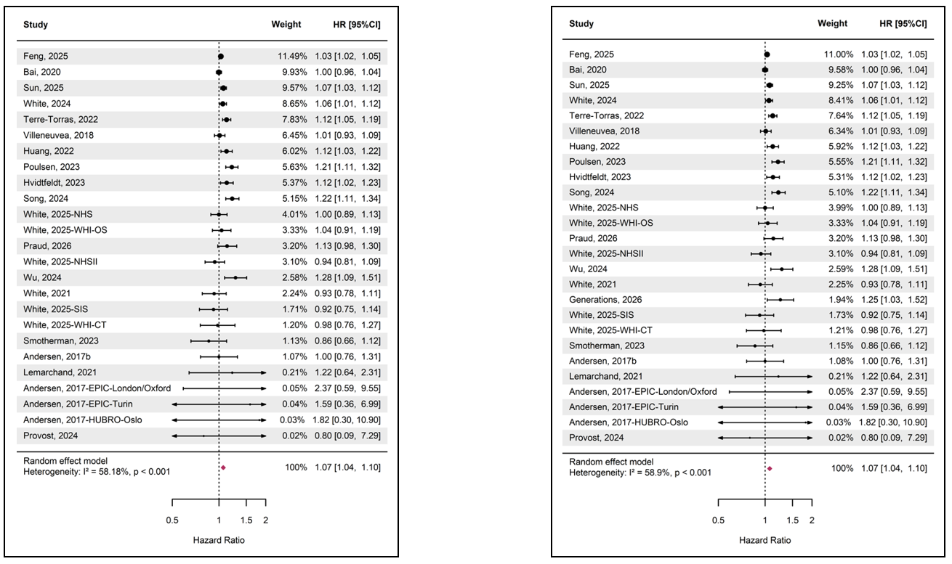
Note: The size of the black dots represents the weight of each study, calculated as the inverse of the total variance (within-study variance plus estimated between-study variance). The red diamond indicates the pooled effect estimate for the association between long-term exposure to PM_{2.5} and female breast cancer incidence
Figure 2 Forest plot of the association between long-term exposure to PM_{2.5} and female breast cancer incidence using a random-effects model (per 10 μg/m³ increase): (A) Studies from the systematic review; (B) Studies from the systematic review + Generations study
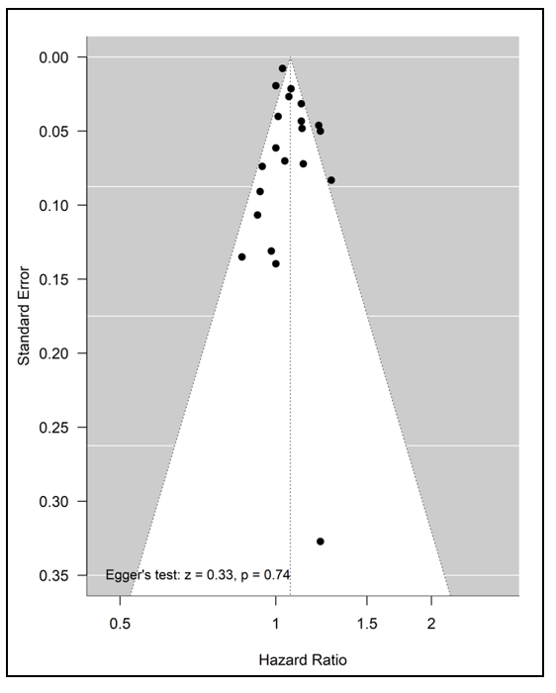
Note: Each black dot represents an individual study. The dashed vertical line indicates the pooled effect estimate. Provost’s study with a standard error of 1.13 was not shown in the funnel plot due to axis range limitations (67)

Figure 3 Funnel plot assessing publication bias in studies of long-term PM_{2.5} exposure and female breast cancer incidence

A-1 A-2
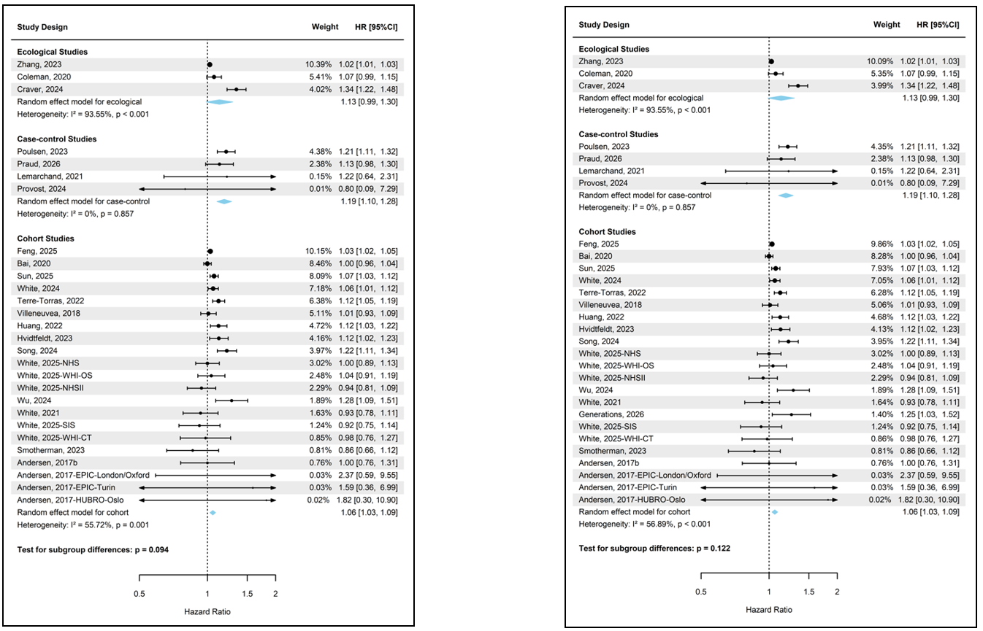

B-1 B-2
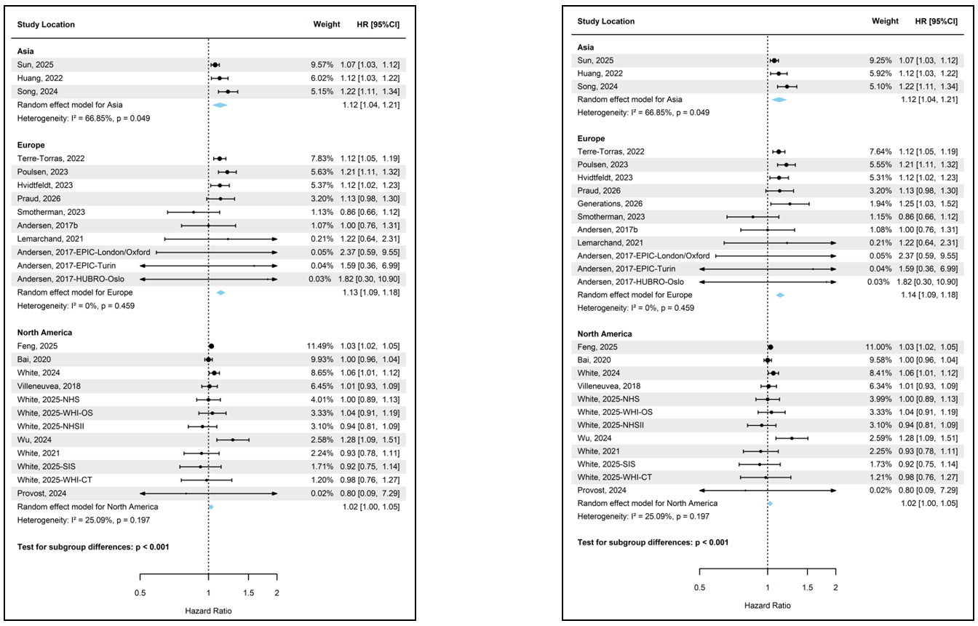

C-1 C-2
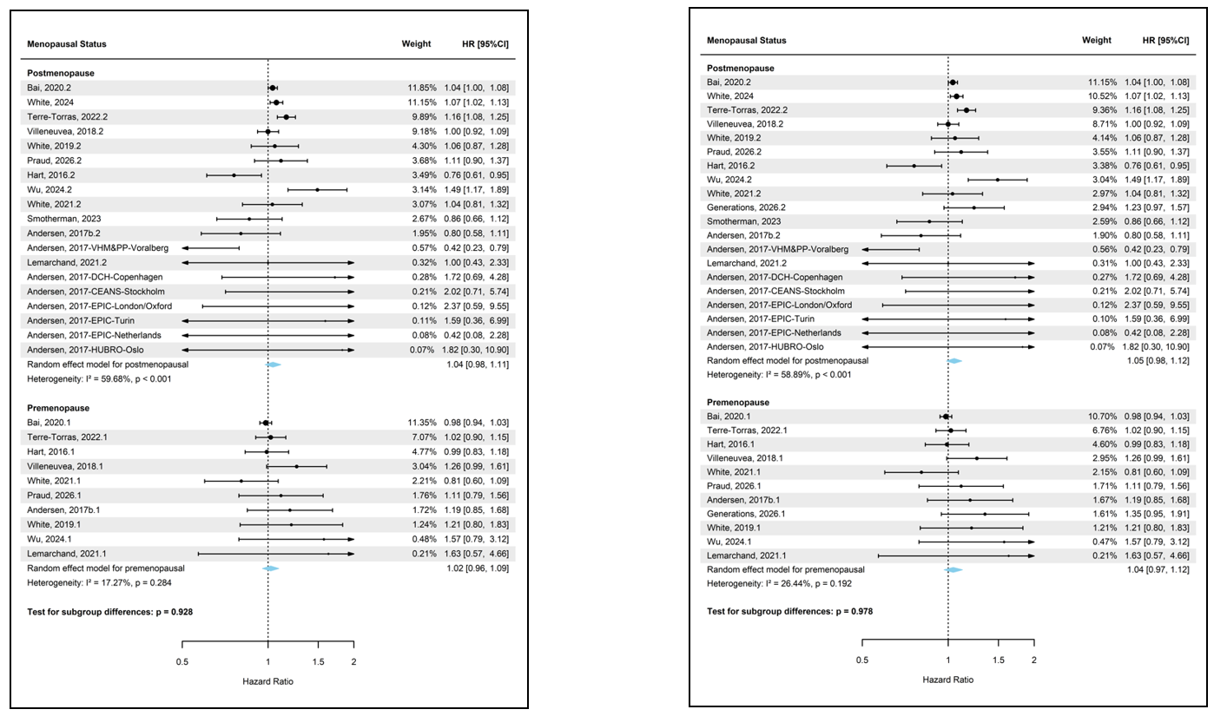

D-1 D-2
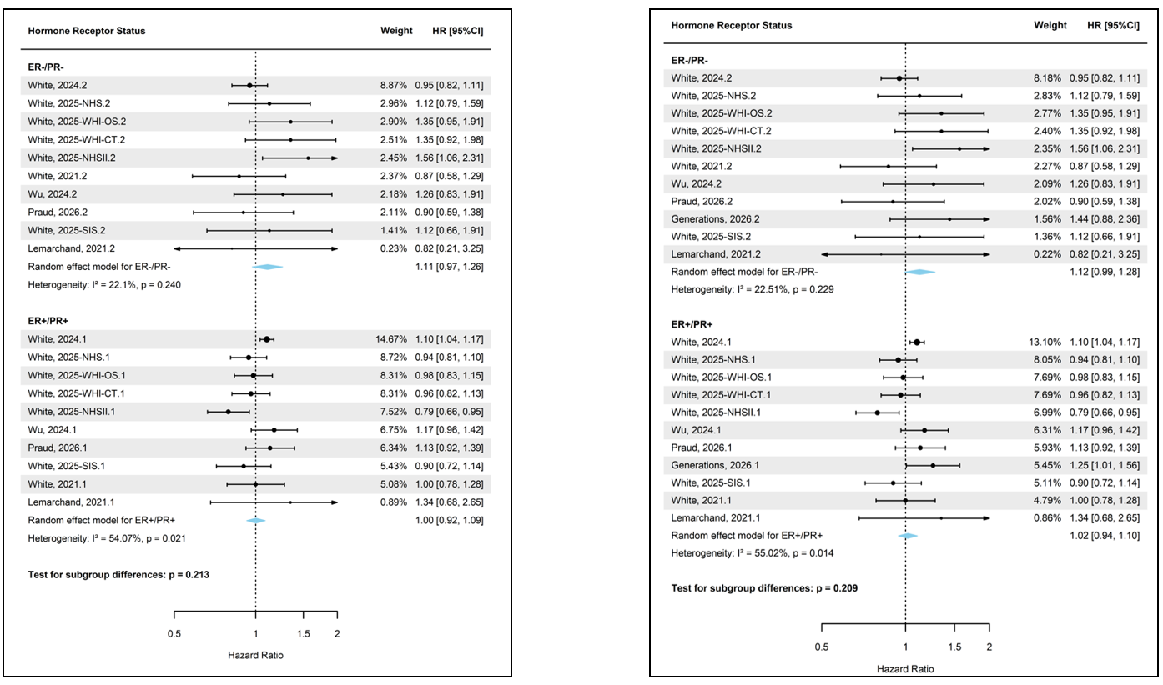

Note: The size of the black dots represents the weight of each study, calculated as the inverse of the total variance (within-study variance plus estimated between-study variance). The blue diamond indicates the pooled effect estimate for each subgroup in the association between long-term exposure to PM_{2.5} and female breast cancer incidence

Figure 4 Subgroup analyses of the association between long-term PM_{2.5} exposure and female breast cancer incidence by (A) study design, (B) study location, (C) menopausal status, and (D) tumour subtype (per 10 μg/m³ increase): (1) Studies from the systematic review; (2) Studies from the systematic review + Generations study
A B
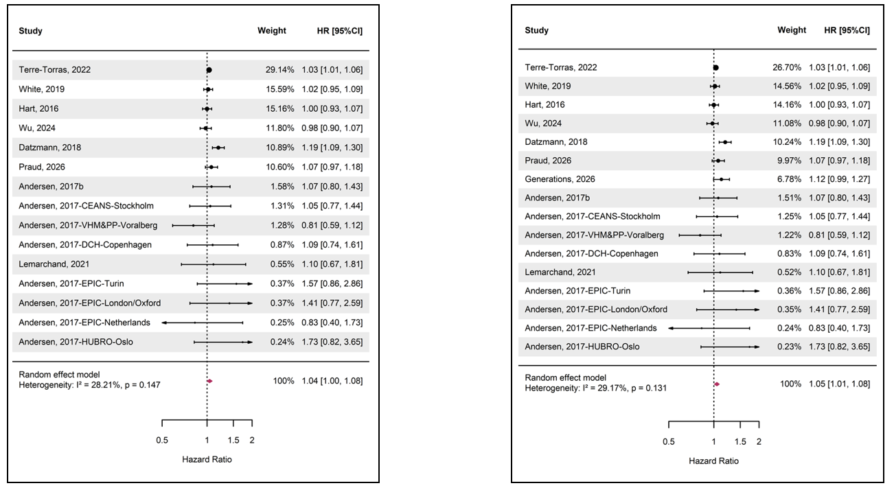
Note: The size of the black dots represents the weight of each study, calculated as the inverse of the total variance (within-study variance plus estimated between-study variance). The red diamond indicates the pooled effect estimate for the association between long-term exposure to PM₁₀ and female breast cancer incidence
Figure 5 Forest plot of the association between long-term exposure to PM₁₀ and female breast cancer incidence using a random-effects model (per 10 μg/m³ increase): (A) Studies from the systematic review; (B) Studies from the systematic review + Generations study
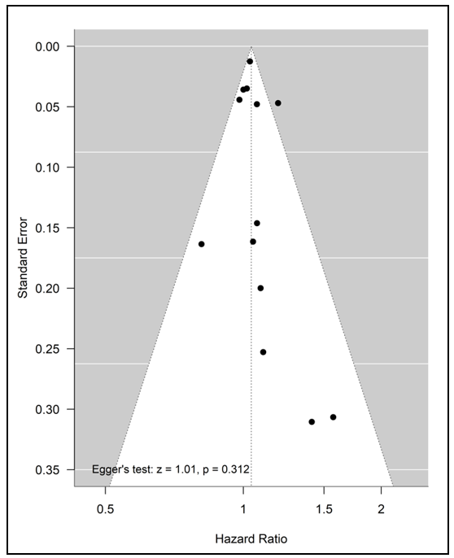
Note: Each black dot represents an individual study. The dashed vertical line indicates the pooled effect estimate.

Figure 6 Funnel plot assessing publication bias in studies of long-term PM₁₀ exposure and female breast cancer incidence
A-1 A-2
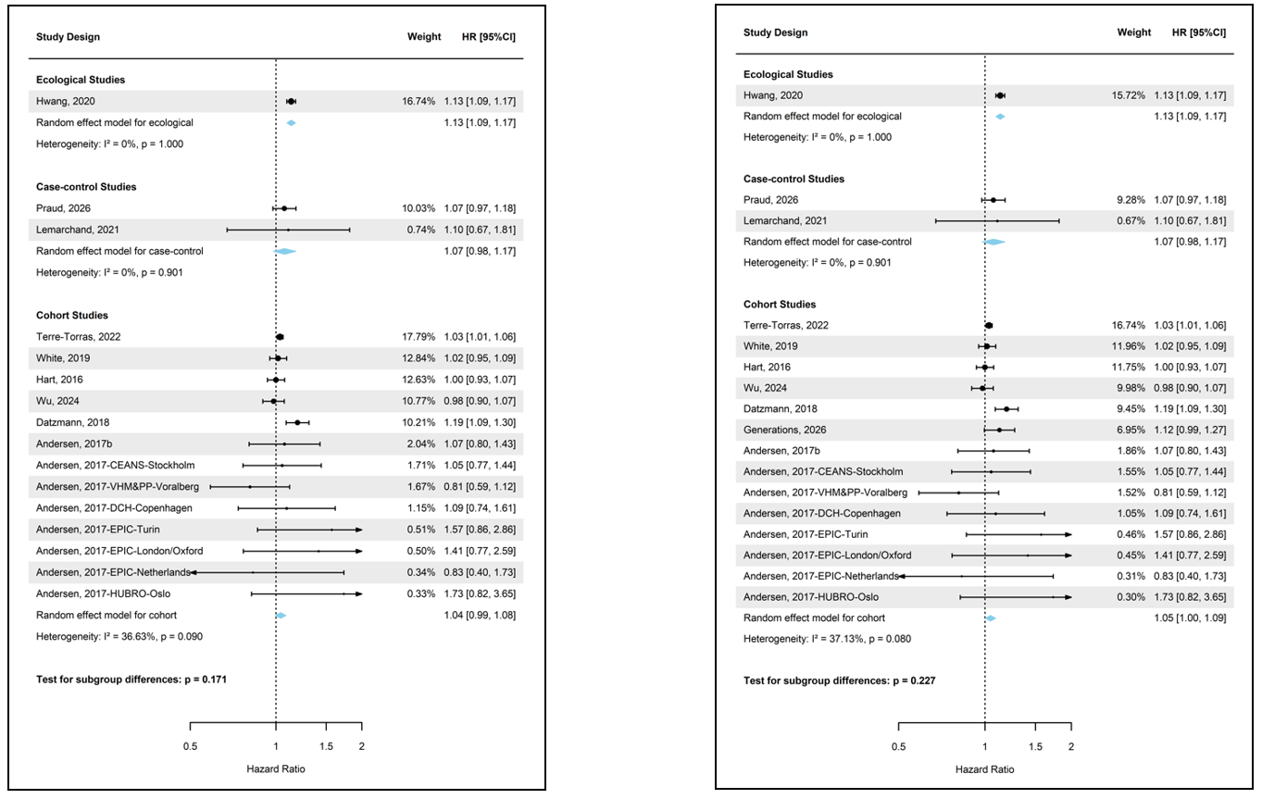

B-1 B-2
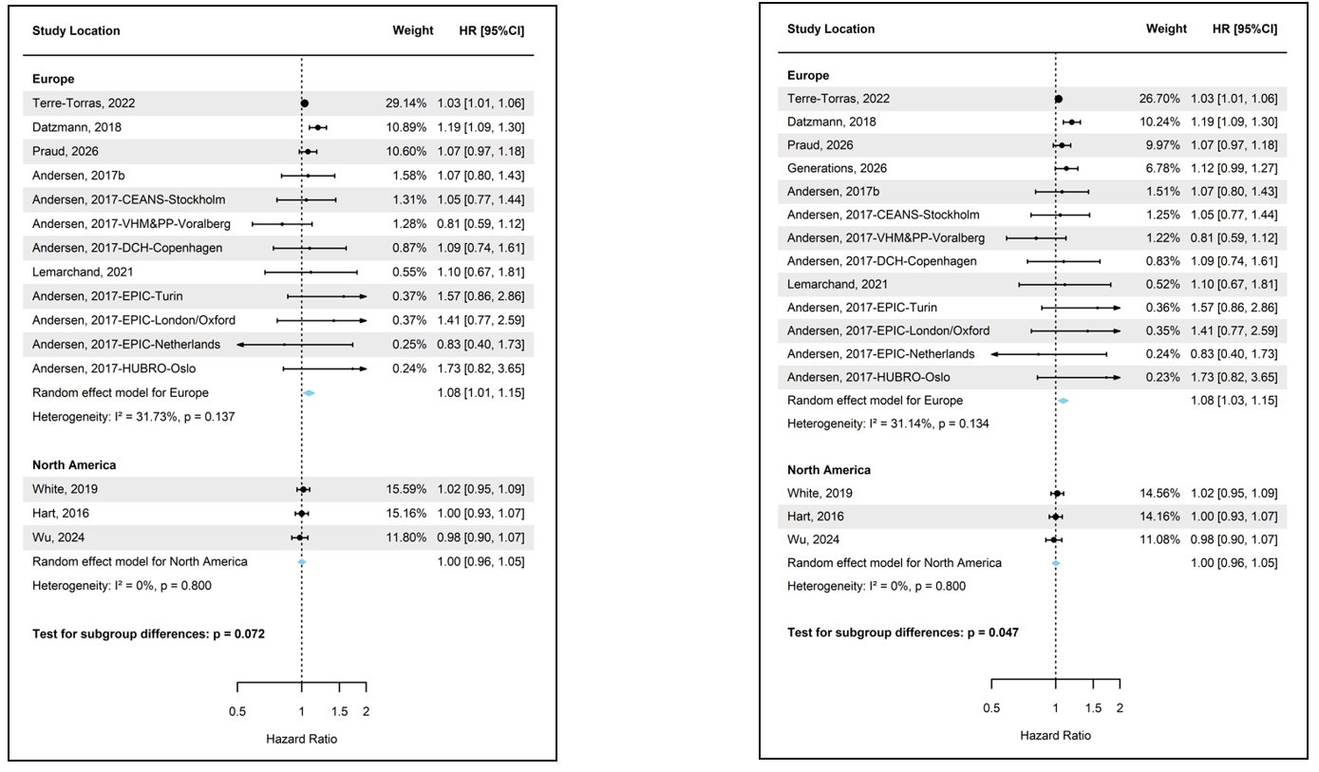

C-1 C-2
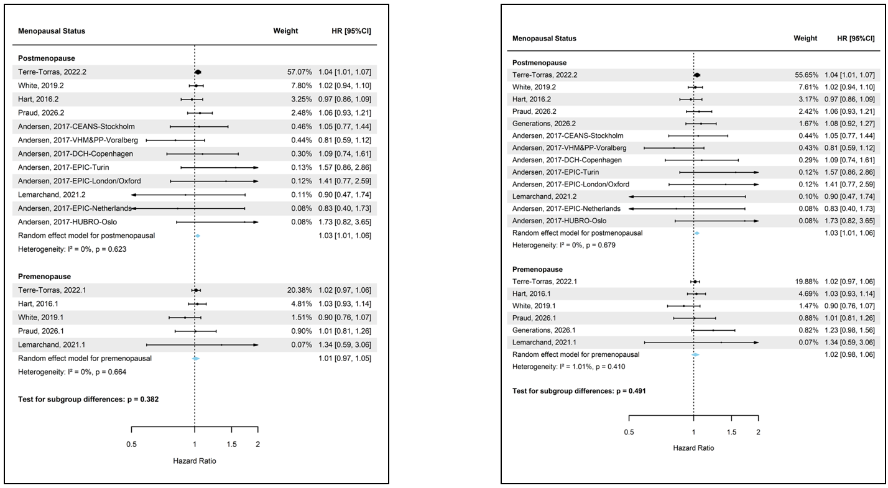

D-1 D-2
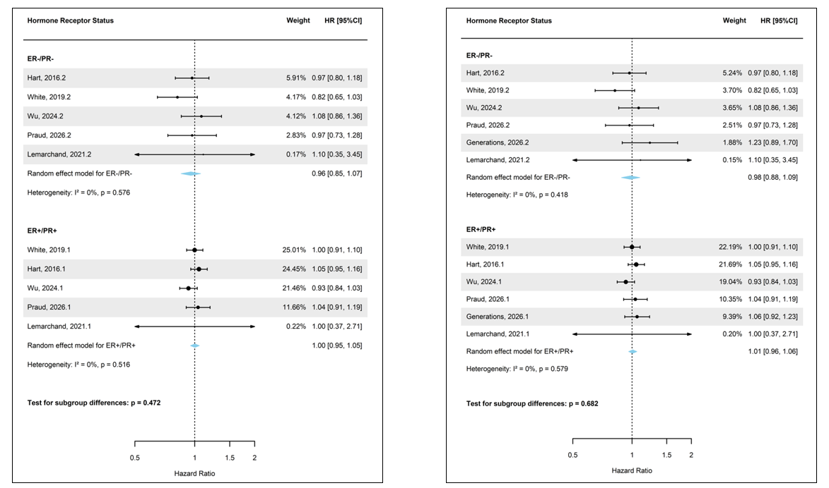
Note: The size of the black dots represents the weight of each study, calculated as the inverse of the total variance (within-study variance plus estimated between-study variance). The blue diamond indicates the pooled effect estimate for each subgroup in the association between long-term exposure to PM₁₀ and female breast cancer incidence

Figure 7 Subgroup analyses of the association between long-term PM₁₀ exposure and female breast cancer incidence by (A) study design, (B) study location, (C) menopausal status, and (D) tumour subtype (per 10 μg/m³ increase): (1) Studies from the systematic review; (2) Studies from the systematic review + Generations study

A
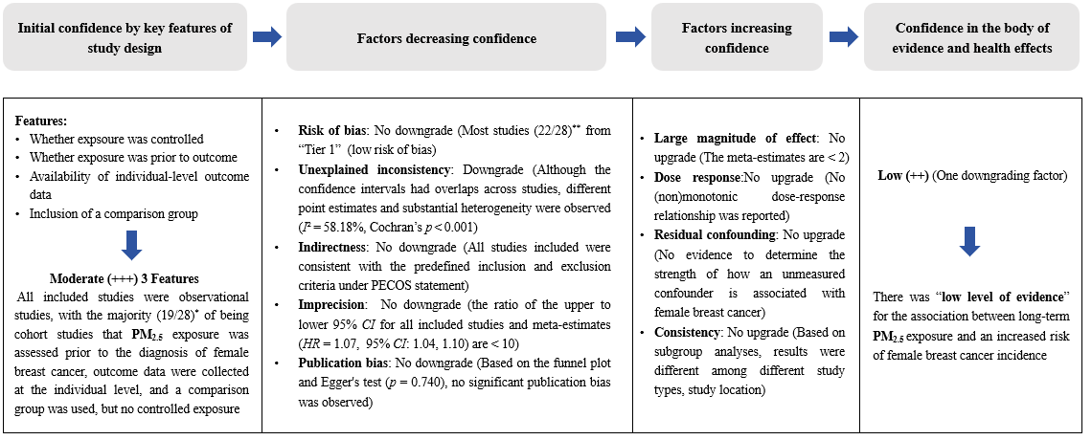
Note: *: Out of the 28 studies on PM2.5, 19 studies were cohort studies; **: Of these, 22 studies were rated as “Tier 1” (low risk of bias)

B
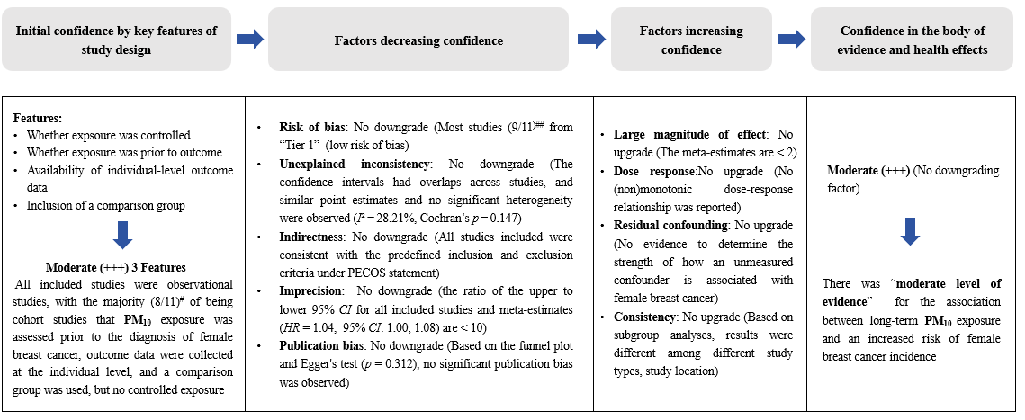
Note: #: Out of the 11 studies on PM₁₀, 8 studies were cohort studies; ##: Of these, 9 studies were rated as “Tier 1” (low risk of bias)

Figure 8 Confidence of the overall evidence for the association between long-term PM_{2.5} (A), PM₁₀ (B) and female breast cancer using Grading of Recommendations Assessment, Development, and Evaluation (GRADE) framework

Appendices
Appendix Table S1 Preferred Reporting Items for Systematic reviews and Meta-Analysis (PRISMA) 2020 Checklist
Section and Topic | Item # | Checklist item | Location where item is reported
TITLE
Title | 1 | Identify the report as a systematic review. | Page 1
ABSTRACT
Abstract | 2 | See the PRISMA 2020 for Abstracts checklist. | Page 11-12
INTRODUCTION
Rationale | 3 | Describe the rationale for the review in the context of existing knowledge. | Page 13-18
Objectives | 4 | Provide an explicit statement of the objective(s) or question(s) the review addresses. | Page 18
METHODS
Eligibility criteria | 5 | Specify the inclusion and exclusion criteria for the review and how studies were grouped for the syntheses. | Page 19-20
Information sources | 6 | Specify all databases, registers, websites, organisations, reference lists and other sources searched or consulted to identify studies. Specify the date when each source was last searched or consulted. | Page 19
Search strategy | 7 | Present the full search strategies for all databases, registers and websites, including any filters and limits used. | Page 79
Selection process | 8 | Specify the methods used to decide whether a study met the inclusion criteria of the review, including how many reviewers screened each record and each report retrieved, whether they worked independently, and if applicable, details of automation tools used in the process. | Page 19-20
Data collection process | 9 | Specify the methods used to collect data from reports, including how many reviewers collected data from each report, whether they worked independently, any processes for obtaining or confirming data from study investigators, and if applicable, details of automation tools used in the process. | Page 20
Data items | 10a | List and define all outcomes for which data were sought. Specify whether all results that were compatible with each outcome domain in each study were sought (e.g. for all measures, time points, analyses), and if not, the methods used to decide which results to collect. | Page 20-21
Data items | 10b | List and define all other variables for which data were sought (e.g. participant and intervention characteristics, funding sources). Describe any assumptions made about any missing or unclear information. | Page 20
Study risk of bias assessment | 11 | Specify the methods used to assess risk of bias in the included studies, including details of the tool(s) used, how many reviewers assessed each study and whether they worked independently, and if applicable, details of automation tools used in the process. | Page 20-21
Effect measures | 12 | Specify for each outcome the effect measure(s) (e.g. risk ratio, mean difference) used in the synthesis or presentation of results. | Page 21
Synthesis methods | 13a | Describe the processes used to decide which studies were eligible for each synthesis (e.g. tabulating the study intervention characteristics and comparing against the planned groups for each synthesis (item #5)). | Page 21
Synthesis methods | 13b | Describe any methods required to prepare the data for presentation or synthesis, such as handling of missing summary statistics, or data conversions. | Page 21
Synthesis methods | 13c | Describe any methods used to tabulate or visually display results of individual studies and syntheses. | Page 21-22
Synthesis methods | 13d | Describe any methods used to synthesize results and provide a rationale for the choice(s). If meta-analysis was performed, describe the model(s), method(s) to identify the presence and extent of statistical heterogeneity, and software package(s) used. | Page 22
Synthesis methods | 13e | Describe any methods used to explore possible causes of heterogeneity among study results (e.g. subgroup analysis, meta-regression). | Page 22
Synthesis methods | 13f | Describe any sensitivity analyses conducted to assess robustness of the synthesized results. | Page 22
Reporting bias assessment | 14 | Describe any methods used to assess risk of bias due to missing results in a synthesis (arising from reporting biases). | Page 21
Certainty assessment | 15 | Describe any methods used to assess certainty (or confidence) in the body of evidence for an outcome. | Page 22-23
RESULTS
Study selection | 16a | Describe the results of the search and selection process, from the number of records identified in the search to the number of studies included in the review, ideally using a flow diagram. | Page 24-25
Study selection | 16b | Cite studies that might appear to meet the inclusion criteria, but which were excluded, and explain why they were excluded. | Page 24-25
Study characteristics | 17 | Cite each included study and present its characteristics. | Page 24-31
Risk of bias in studies | 18 | Present assessments of risk of bias for each included study. | Page 32-36
Results of individual studies | 19 | For all outcomes, present, for each study: (a) summary statistics for each group (where appropriate) and (b) an effect estimate and its precision (e.g. confidence/credible interval), ideally using structured tables or plots. | Page 37-47
Results of syntheses | 20a | For each synthesis, briefly summarise the characteristics and risk of bias among contributing studies. | Page 37, 42
Results of syntheses | 20b | Present results of all statistical syntheses conducted. If meta-analysis was done, present for each the summary estimate and its precision (e.g. confidence/credible interval) and measures of statistical heterogeneity. If comparing groups, describe the direction of the effect. | Page 37, 42
Results of syntheses | 20c | Present results of all investigations of possible causes of heterogeneity among study results. | Page 38-41, 43-46
Results of syntheses | 20d | Present results of all sensitivity analyses conducted to assess the robustness of the synthesized results. | Page 47
Reporting biases | 21 | Present assessments of risk of bias due to missing results (arising from reporting biases) for each synthesis assessed. | Page 38, 43
Certainty of evidence | 22 | Present assessments of certainty (or confidence) in the body of evidence for each outcome assessed. | Page 47-50
DISCUSSION
Discussion | 23a | Provide a general interpretation of the results in the context of other evidence. | Page 51-54
Discussion | 23b | Discuss any limitations of the evidence included in the review. | Page 57-58
Discussion | 23c | Discuss any limitations of the review processes used. | Page 57-58
Discussion | 23d | Discuss implications of the results for practice, policy, and future research. | Page 58-59
OTHER INFORMATION
Registration and protocol | 24a | Provide registration information for the review, including register name and registration number, or state that the review was not registered. | Page 19
Registration and protocol | 24b | Indicate where the review protocol can be accessed, or state that a protocol was not prepared. | Page 19
Registration and protocol | 24c | Describe and explain any amendments to information provided at registration or in the protocol. | No information
Support | 25 | Describe sources of financial or non-financial support for the review, and the role of the funders or sponsors in the review. | No information
Competing interests | 26 | Declare any competing interests of review authors. | No information
Availability of data, code and other materials | 27 | Report which of the following are publicly available and where they can be found: template data collection forms; data extracted from included studies; data used for all analyses; analytic code; any other materials used in the review. | No information
(Continued)
Appendix Table S2 Literature Search Strategies (from 1 January 2010)
Databases | Search Strategies | Previous Results (to 13 June 2025) | Updated Results  (to 18 March 2026)
PubMed | ("particulate matter"[Title/Abstract] OR "PM"[Title/Abstract] OR "particles"[Title/Abstract] OR "PM2.5"[Title/Abstract] OR "PM10"[Title/Abstract] OR "ultrafine particles"[Title/Abstract] OR "air pollution"[Title/Abstract] OR "air pollutant"[Title/Abstract] OR "atmospheric pollution"[Title/Abstract] OR "atmospheric pollutant"[Title/Abstract] OR "particulate matter"[MeSH Terms] OR "air pollution"[MeSH Terms] OR "air pollutants"[MeSH Terms]) AND ("breast cancer"[Title/Abstract] OR "breast neoplasm"[Title/Abstract] OR "breast tumor"[Title/Abstract] OR "breast carcinoma"[Title/Abstract] OR "breast neoplasms"[MeSH Terms]) | 2,219 | 2,382
Web of Science | "particulate matter" OR "PM" OR "particles" OR "PM2.5" OR "PM10" OR "ultrafine particles" OR air pollut* OR atmospheric pollut* (Topic) and "breast cancer" OR "breast neoplasm" OR breast tumo$r OR "breast carcinoma" (Topic) | 4,265 | 4,517
Embase | ((particulate matter or PM or particles or PM2.5 or PM10 or ultrafine particles or air pollut* or atmospheric pollut*) and (breast cancer or breast neoplasm or breast tumo$r or breast carcinoma)).mp. [mp=title, abstract, heading word, drug trade name, original title, device manufacturer, drug manufacturer, device trade name, keyword heading word, floating subheading word, candidate term word] | 4,500 | 4,911

Appendix Table S3A-Adapted Newcastle Ottawa quality assessment scale for COHORT studies
Selection | S1 | Representativeness of the exposed cohort | a) Truly representative of the general female population in the community (e.g., national registry, census-based cohort) ☆
Selection | S1 | Representativeness of the exposed cohort | b) Somewhat representative of the average female population in the community (e.g., large regional cohort) ☆
Selection | S1 | Representativeness of the exposed cohort | c) Selected group (e.g., volunteers, nurses, patients in screening programs)
Selection | S1 | Representativeness of the exposed cohort | d) No description of the derivation of the cohort
Selection | S2 | Selection of the non-exposed cohort | a) Drawn from the same community as the exposed cohort (e.g., same geographic cohort with PM variation) ☆
Selection | S2 | Selection of the non-exposed cohort | b) Drawn from a different source (e.g., another region or city)
Selection | S2 | Selection of the non-exposed cohort | c) No description of the derivation of the non-exposed cohort
Selection | S3 | Ascertainment of exposure | a) Objectively defined data (e.g. modelled estimates or measured concentrations for air quality monitoring stations) ☆
Selection | S3 | Ascertainment of exposure | b) Self report or no description
Selection | S4 | Demonstration that outcome of interest was not present at start of study | a) Yes, baseline excludes prevalent breast cancer cases ☆
Selection | S4 |  | b) No, outcome status at baseline unclear or not reported
Comparability | C1 | Comparability of cohorts on the basis of the design or analysis | a) Study controls for the most important factor (age or menopausal status) ☆  b) Study controls for at least one additional factor (e.g. socio-economic status, or lifestyle factors (e.g. BMI, smoking, alcohol consumption, physical activity), or reproductive factors (e.g. parity, hormone therapy use, use of oral contraceptive), or breast cancer family history ☆
Outcome | O1 | Assessment of outcome | a) Independent blind assessment of breast cancer (e.g., linkage to registry with on exposure knowledge) ☆
Outcome | O1 | Assessment of outcome | b) Record linkage to national/regional cancer registries or medical records with clear diagnostic coding ☆
Outcome | O1 | Assessment of outcome | c) Outcome based on modelled or estimated breast cancer rates without registry validation
Outcome | O1 | Assessment of outcome | d) No description
Outcome | O2 | Was follow-up long enough for outcomes to occur | a) Yes, at least 5-10 years of follow-up ☆
Outcome | O2 | Was follow-up long enough for outcomes to occur | b) No
Outcome | O3 | Adequacy of follow up of cohorts | a) Complete follow up, with minimal loss (<10%) and all participants accounted for ☆
Outcome | O3 | Adequacy of follow up of cohorts | b) Subjects lost to follow up unlikely to introduce bias-small number lost-≥ 80% follow up, or description of those lost
Outcome | O3 | Adequacy of follow up of cohorts | c) Follow up rate <80% and no description of those lost
Outcome | O3 | Adequacy of follow up of cohorts | d) No statement

Appendix Table S3B-Adapted Newcastle Ottawa quality assessment scale for CASE-CONTROL studies
Selection | S1 | Is the case definition adequate? | a) Yes, breast cancer diagnosis was confirmed through histology, registry data, or medical records (e.g. ICD-9 174, ICD-10 C50) ☆
Selection | S1 | Is the case definition adequate? | b) Yes, self-report without pathological records confirmed
Selection | S1 | Is the case definition adequate? | c) No description
Selection | S2 | Representativeness of the cases | a) All eligible cases with outcome of interest over a defined period of time, all cases in a defined catchment area, all cases in a defined hospital or clinic, group of hospitals, health maintenance organisation, or an appropriate sample of those cases (e.g. random sample) ☆
Selection | S2 | Representativeness of the cases | b) Not satisfying requirements in part (a), or not stated
Selection | S3 | Selection of controls | a) Community controls (i.e. same community as cases and would be cases if had outcome) ☆
Selection | S3 | Selection of controls | b) Hospital controls, within same community as cases (i.e. not another city) but derived from a hospitalised population
Selection | S3 | Selection of controls | c) No description
Selection | S4 | Definition of controls | a) No history of breast cancer ☆
Selection | S4 | Definition of controls | b) No description of source (No mention of history of breast cancer)
Comparability | C1 | Comparability of cases and controls on the basis of the design or analysis | a) Study controls for the most important factor (age or menopausal status) ☆  b) Study controls for at least one additional factor (e.g. socio-economic status, or lifestyle factors (e.g. BMI, smoking, alcohol consumption, physical activity), or reproductive factors (e.g. parity, hormone therapy use, use of oral contraceptive), or breast cancer family history ☆
Exposure | E1 | Ascertainment of exposure | a) Objectively defined data (e.g. modelled estimates or measured concentrations for air quality monitoring stations) ☆
Exposure | E1 | Ascertainment of exposure | b) Self report or no description
Exposure | E2 | Same method of ascertainment for cases and controls | a) Yes ☆
Exposure | E2 | Same method of ascertainment for cases and controls | b) No
Exposure | E3 | Non-response rate | a) Same or similar rate for both groups (within ± 5-10%) ☆
Exposure | E3 | Non-response rate | b) Non-respondents described
Exposure | E3 | Non-response rate | c) Rate different and no designation

Appendix Table S3C-Adapted Newcastle Ottawa quality assessment scale for ECOLOGICAL studies
Selection | S1 | Representativeness of the exposed population | a) Truly representative of the general female population in the community (e.g., entire country or large region) ☆
Selection | S1 | Representativeness of the exposed population | b) Somewhat representative of the average population in the community (e.g., multiple regions or cities) ☆
Selection | S1 | Representativeness of the exposed population | c) Population includes a single city/region or only urban/rural area without justification of representativeness
Selection | S1 | Representativeness of the exposed population | d) No description of the derivation of the study population
Selection | S2 | Representativeness of the non- exposed population | a) Drawn from the same community as the exposed population (e.g., same geographic population with PM variation) ☆
Selection | S2 | Representativeness of the non- exposed population | b) Drawn from a different source (e.g., another region or city)
Selection | S2 | Representativeness of the non- exposed population | c) No description of the derivation of the non-exposed population
Selection | S3 | Ascertainment of exposure | a) Objectively defined data (e.g. modelled estimates or measured concentrations for air quality monitoring stations) ☆
Selection | S3 | Ascertainment of exposure | b) Self report or no description
Selection | S4 | Demonstration that outcome of interest was not present at start of study | a) Yes, baseline excludes prevalent breast cancer cases ☆
Selection | S4 |  | b) No, outcome status at baseline unclear or not reported
Comparability | C1 | Comparability of exposed and non- exposed groups on the basis of the design or analysis | a) Study controls for the most important factor (age or menopausal status) ☆  b) Study controls for at least one additional factor at area level (e.g. socio-economic status, or lifestyle factors (e.g. the percentage of obesity, smoking, alcohol consumption, physical activity), or reproductive factors (e.g. parity, hormone therapy use, use of oral contraceptive), or breast cancer family history ☆
Outcome | O1 | Assessment of outcome | a) Independent blind assessment of breast cancer (e.g., linkage to registry with on exposure knowledge) ☆
Outcome | O1 | Assessment of outcome | b) Record linkage to national/regional cancer registries with clear diagnostic coding ☆
Outcome | O1 | Assessment of outcome | c) Outcome based on modelled or estimated cancer rates without registry validation
Outcome | O1 | Assessment of outcome | d) No description
Outcome | O2 | Statistical analysis quality | a) Appropriate regression (e.g., spatial models, Poisson) accounting for spatial autocorrelation or area-level covariates ☆
Outcome | O2 | Statistical analysis quality | b) Simpler regression methods with some limitations discussed ☆
Outcome | O2 | Statistical analysis quality | c) Crude correlation analysis (e.g., Pearson’s r) without proper modelling
Outcome | O2 | Statistical analysis quality | d) No description
Outcome | O3 | Ecological bias awareness | a) Discusses ecological fallacy and clearly states limitations ☆
Outcome | O3 | Ecological bias awareness | b) Mentions limitations briefly
Outcome | O3 | Ecological bias awareness | c) No discussion of ecological inference limitations
Note: A study can be awarded a maximum of one star for each numbered item within the Selection and Exposure categories. A maximum of two stars can be given for Comparability

Omitting Study | HR (95%CI) | p value | I² | Heterogeneity p value
-Feng, 2025 | 1.14 (1.05, 1.22) | <0.001 | 90.71% | <0.001
-Bai, 2020 | 1.13 (1.06, 1.21) | <0.001 | 90.87% | <0.001
-Sun, 2025 | 1.13 (1.06, 1.2) | <0.001 | 91.04% | <0.001
-White, 2024 | 1.13 (1.06, 1.2) | <0.001 | 91.07% | <0.001
-Terre-Torras, 2022 | 1.12 (1.05, 1.19) | <0.001 | 90.92% | <0.001
-Villeneuvea, 2018 | 1.13 (1.06, 1.2) | <0.001 | 91.05% | <0.001
-Huang, 2022 | 1.12 (1.06, 1.19) | <0.001 | 91.00% | <0.001
-Poulsen, 2023 | 1.12 (1.05, 1.18) | <0.001 | 90.73% | <0.001
-Hvidtfeldt, 2023 | 1.12 (1.06, 1.19) | <0.001 | 91.01% | <0.001
-Song, 2024 | 1.12 (1.05, 1.18) | <0.001 | 90.76% | <0.001
-White, 2025-NHS | 1.13 (1.06, 1.2) | <0.001 | 91.06% | <0.001
-White, 2025-WHI-OS | 1.13 (1.06, 1.19) | <0.001 | 91.08% | <0.001
-Praud, 2026 | 1.12 (1.06, 1.19) | <0.001 | 91.04% | <0.001
-White, 2025-NHSII | 1.13 (1.06, 1.2) | <0.001 | 91.01% | <0.001
-Wu, 2024 | 1.11 (1.05, 1.18) | <0.001 | 90.88% | <0.001
-White, 2021 | 1.13 (1.06, 1.2) | <0.001 | 91.02% | <0.001
-White, 2025-SIS | 1.13 (1.06, 1.2) | <0.001 | 91.03% | <0.001
-Kayyal-Tarabeia, 2024 | 1.07 (1.04, 1.1) | <0.001 | 58.18% | <0.001
-White, 2025-WHI-CT | 1.13 (1.06, 1.19) | <0.001 | 91.07% | <0.001
-Smotherman, 2023 | 1.13 (1.06, 1.2) | <0.001 | 91.01% | <0.001
-Andersen, 2017b | 1.12 (1.06, 1.19) | <0.001 | 91.08% | <0.001
-Lemarchand, 2021 | 1.12 (1.06, 1.19) | <0.001 | 91.07% | <0.001
-Andersen, 2017-EPIC-London/Oxford | 1.12 (1.06, 1.19) | <0.001 | 91.04% | <0.001
-Andersen, 2017-EPIC-Turin | 1.12 (1.06, 1.19) | <0.001 | 91.07% | <0.001
-Andersen, 2017-HUBRO-Oslo | 1.12 (1.06, 1.19) | <0.001 | 91.07% | <0.001
-Provost, 2024 | 1.12 (1.06, 1.19) | <0.001 | 91.08% | <0.001
Appendix Table S4A Leave-one-out analysis with ALL studies on the association between long-term PM_{2.5} exposure and female breast cancer incidence
Appendix Table S4B Leave-one-out analysis WITHOUT Kayyal-Tarabeia’s study (2024) on the association between long-term PM_{2.5} exposure and female breast cancer incidence
Omitting Study | HR (95%CI) | p value | I² | Heterogeneity p value
-Feng, 2025 | 1.07 (1.03, 1.11) | <0.001 | 55.21% | <0.001
-Bai, 2020 | 1.07 (1.04, 1.11) | <0.001 | 55.94% | <0.001
-Sun, 2025 | 1.07 (1.03, 1.1) | <0.001 | 58.78% | <0.001
-White, 2024 | 1.07 (1.03, 1.1) | <0.001 | 59.64% | <0.001
-Terre-Torras, 2022 | 1.06 (1.03, 1.09) | <0.001 | 55.74% | <0.001
-Villeneuvea, 2018 | 1.07 (1.04, 1.1) | <0.001 | 59.47% | <0.001
-Huang, 2022 | 1.06 (1.03, 1.1) | <0.001 | 57.86% | <0.001
-Poulsen, 2023 | 1.06 (1.03, 1.09) | <0.001 | 50.85% | 0.002
-Hvidtfeldt, 2023 | 1.06 (1.03, 1.1) | <0.001 | 58.14% | <0.001
-Song, 2024 | 1.06 (1.03, 1.09) | <0.001 | 51.56% | 0.002
-White, 2025-NHS | 1.07 (1.04, 1.1) | <0.001 | 59.59% | <0.001
-White, 2025-WHI-OS | 1.07 (1.04, 1.1) | <0.001 | 59.92% | <0.001
-Praud, 2026 | 1.06 (1.03, 1.1) | <0.001 | 59.03% | <0.001
-White, 2025-NHSII | 1.07 (1.04, 1.1) | <0.001 | 58.51% | <0.001
-Wu, 2024 | 1.06 (1.03, 1.09) | <0.001 | 55.14% | <0.001
-White, 2021 | 1.07 (1.04, 1.1) | <0.001 | 58.82% | <0.001
-White, 2025-SIS | 1.07 (1.04, 1.1) | <0.001 | 58.96% | <0.001
-White, 2025-WHI-CT | 1.07 (1.04, 1.1) | <0.001 | 59.77% | <0.001
-Smotherman, 2023 | 1.07 (1.04, 1.1) | <0.001 | 58.45% | <0.001
-Andersen, 2017b | 1.07 (1.04, 1.1) | <0.001 | 59.86% | <0.001
-Lemarchand, 2021 | 1.07 (1.03, 1.1) | <0.001 | 59.76% | <0.001
-Andersen, 2017-EPIC-London/Oxford | 1.07 (1.04, 1.1) | <0.001 | 58.97% | <0.001
-Andersen, 2017-EPIC-Turin | 1.07 (1.04, 1.1) | <0.001 | 59.71% | <0.001

 | Appendix Table S5A Leave-one-out analysis with ALL studies on the association between long-term PM₁₀ exposure and female breast cancer incidence
Omitting Study |  | HR (95%CI) | p value | I² | Heterogeneity p value
-Terre-Torras, 2022 |  | 1.13 (1.01, 1.28) | 0.039 | 87.14% | <0.001
-White, 2019 |  | 1.13 (1.02, 1.26) | 0.018 | 87.64% | <0.001
-Hart, 2016 |  | 1.14 (1.02, 1.26) | 0.015 | 87.51% | <0.001
-Wu, 2024 |  | 1.14 (1.03, 1.26) | 0.011 | 87.45% | <0.001
-Datzmann, 2018 |  | 1.11 (1.01, 1.22) | 0.031 | 86.90% | <0.001
-Praud, 2026 |  | 1.13 (1.02, 1.24) | 0.019 | 87.73% | <0.001
-Smotherman, 2023 |  | 1.04 (1.00, 1.08) | 0.034 | 28.21% | 0.147
-Andersen, 2017b |  | 1.12 (1.02, 1.23) | 0.015 | 87.74% | <0.001
-Andersen, 2017-CEANS-Stockholm |  | 1.12 (1.02, 1.23) | 0.014 | 87.74% | <0.001
-Andersen, 2017-VHM&PP-Voralberg |  | 1.14 (1.04, 1.25) | 0.006 | 87.46% | <0.001
-Andersen, 2017-DCH-Copenhagen |  | 1.12 (1.02, 1.23) | 0.015 | 87.74% | <0.001

 | Appendix Table S5B Leave-one-out analysis WITHOUT Smotherman’s study (2023) on the association between long-term PM₁₀ exposure and female breast cancer incidence
Omitting Study |  | HR (95%CI) | p value | I² | Heterogeneity p value
-Terre-Torras, 2022 |  | 1.05 (0.99, 1.01) | 0.089 | 33.08% | 0.110
-White, 2019 |  | 1.05 (1.00, 1.09) | 0.044 | 32.37% | 0.116
-Hart, 2016 |  | 1.05 (1.01, 1.10) | 0.027 | 29.64% | 0.140
-Wu, 2024 |  | 1.05 (1.01, 1.09) | 0.017 | 27.23% | 0.163
-Datzmann, 2018 |  | 1.03 (1.01, 1.05) | 0.007 | 0.00% | 0.673
-Praud, 2026 |  | 1.04 (1.00, 1.08) | 0.077 | 31.59% | 0.123
-Andersen, 2017b |  | 1.04 (1.00, 1.08) | 0.044 | 33.15% | 0.110
-Andersen, 2017-CEANS-Stockholm |  | 1.04 (1.00, 1.08) | 0.042 | 33.31% | 0.109
-Andersen, 2017-VHM&PP-Voralberg |  | 1.04 (1.01, 1.08) | 0.018 | 24.59% | 0.189
-Andersen, 2017-DCH-Copenhagen |  | 1.04 (1.00, 1.08) | 0.042 | 33.11% | 0.110
-Lemarchand, 2021 |  | 1.04 (1.00, 1.08) | 0.041 | 33.11% | 0.110

Note: *: Although the exclusion of Datzmann et al. (2018) substantially reduced heterogeneity (I² = 0%), I chose to retain this study in the main analysis for the following reasons: (1) Heterogeneity remained statistically non-significant even when the study was included (I² = 28.21%, p for heterogeneity = 0.147), suggesting that its influence on between-study variability was not critical; (2) Removing this study would disproportionately increase the weight of other studies, particularly Terre-Torras et al. (2022) (from 30.59% to 73.09%), which could introduce instability or undue influence on the overall effect estimate; (3) The study by Datzmann et al. included a very large sample size (>1.9 million participants), adding considerable statistical power and generalisability to the pooled estimate. Excluding such a large and high-quality study might risk underestimating the true association
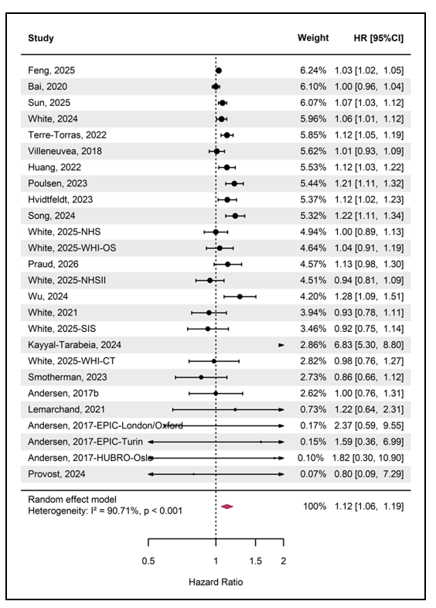
Note: The arrow for Kayyal-Tarabeia et al. (2024) indicated that the point estimate and 95% CI exceeded the displayed axis range. The size of the black dots represents the weight of each study, calculated as the inverse of the total variance (within-study variance plus estimated between-study variance). The red diamond indicates the pooled effect estimate for the association between long-term exposure to PM_{2.5} and female breast cancer incidence

Appendix Figure S1 Forest plot of ALL studies on the association between long-term exposure to PM_{2.5} and female breast cancer incidence using a random-effects model (per 10 μg/m³ increase)
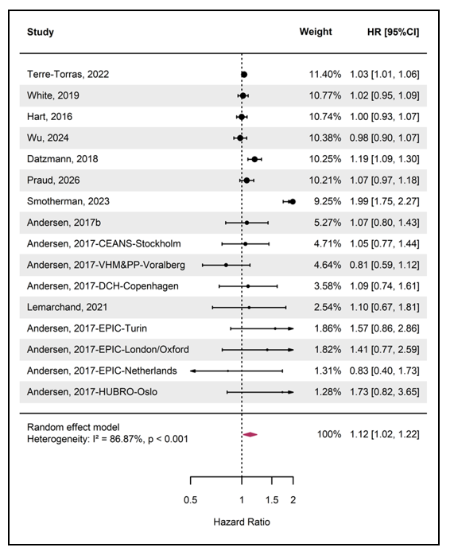
Note: The size of the black dots represents the weight of each study, calculated as the inverse of the total variance (within-study variance plus estimated between-study variance). The red diamond indicates the pooled effect estimate for the association between long-term exposure to PM₁₀ and female breast cancer incidence

Appendix Figure S2 Forest plot of ALL studies on the association between long-term exposure to PM₁₀ and female breast cancer incidence using a random-effects model (per 10 μg/m³ increase)

